# flash touch screen

1.1 modify mks_config

First ，find these file.

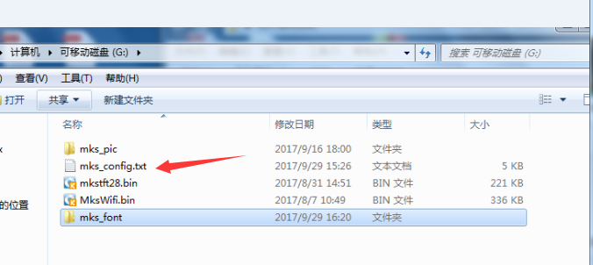

Then open maks_config.txt

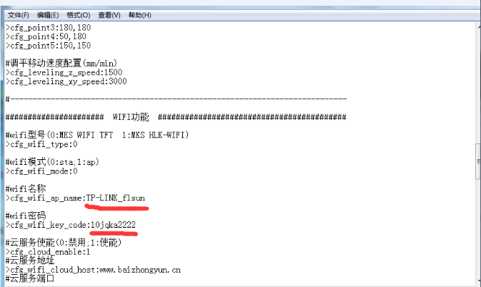

Find >cfg_wifi_ap_name,Fill in your WiFi name.

>cfg_wifi_key_code,Fill in your WiFi password.

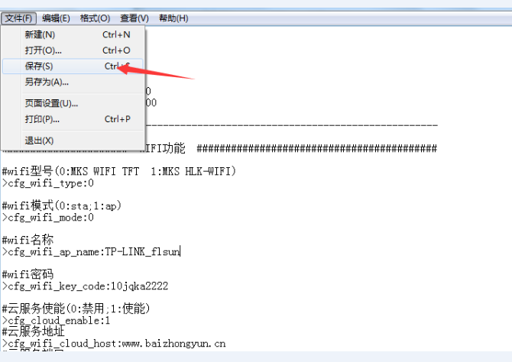

Clcik ‘save’ to save setting.

**Then copy these file in sd card sd card root directory**

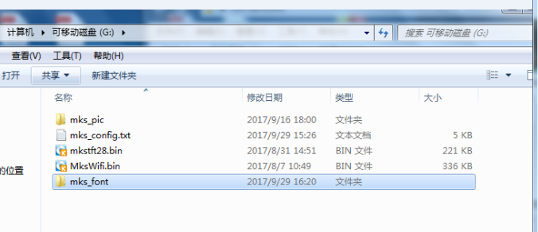

1.2 assemble wifi Module

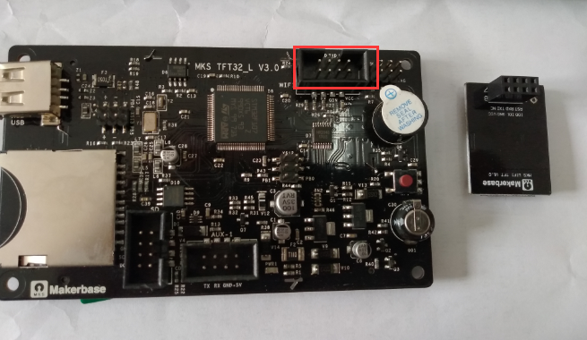

Plug wifi module in this solt.

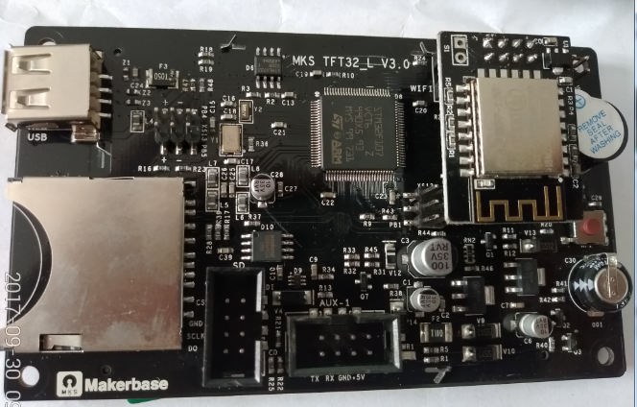

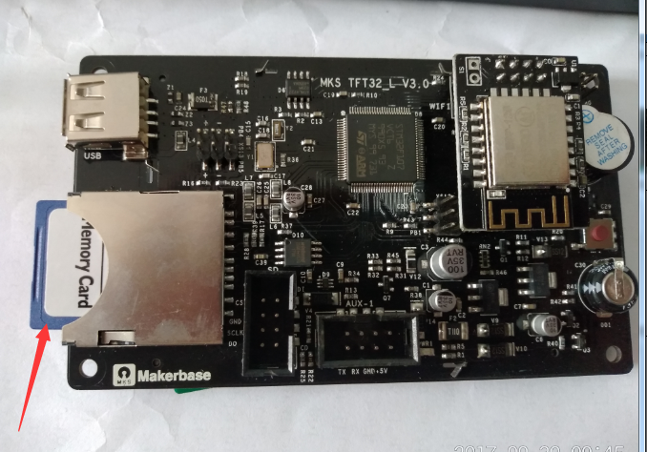

Then plug sd card in sd card slot.

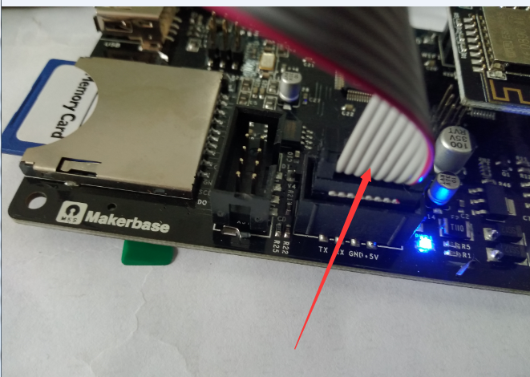

Then connect touch screen and board,turn on power supply.

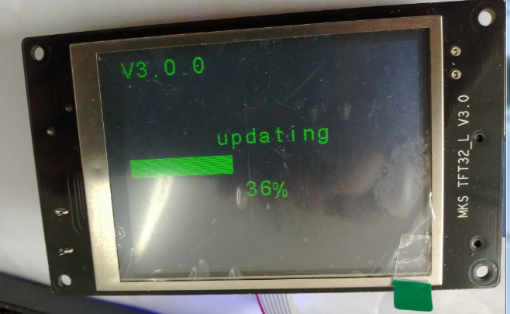

Then the touch screen will be flashed.

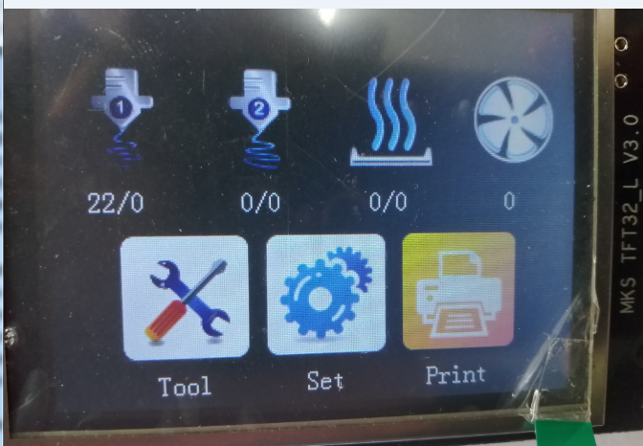

Flash done.

# use app control printer

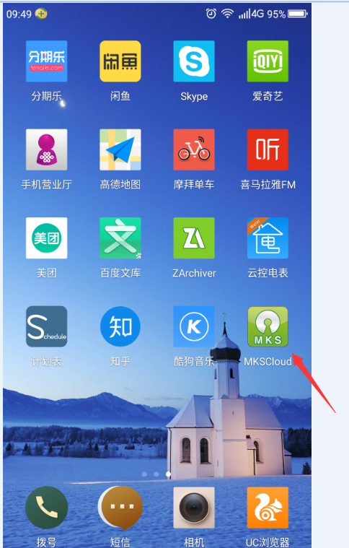

Install the app in Mobile phone.

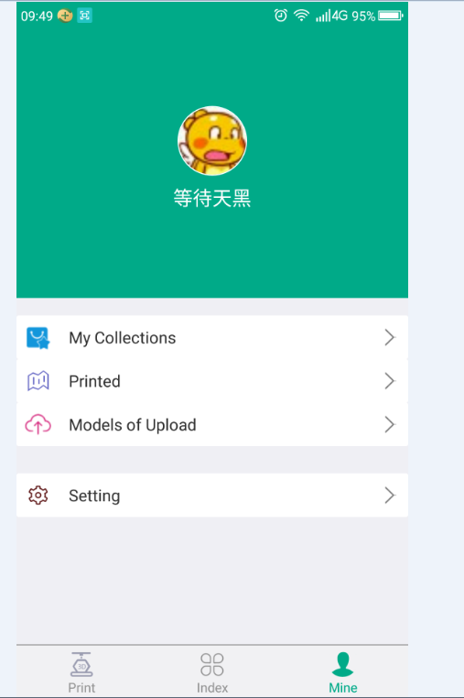

Register an account

If the language is Chinese.you need modify it.

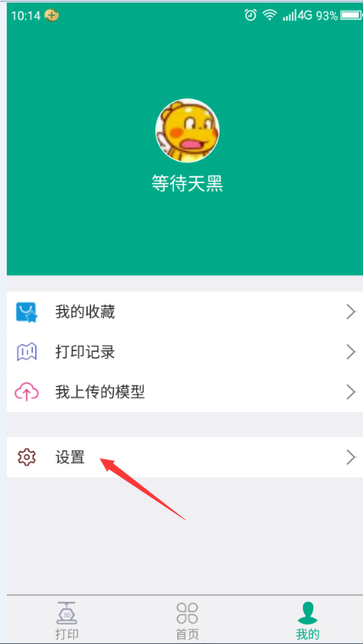

Click this button.

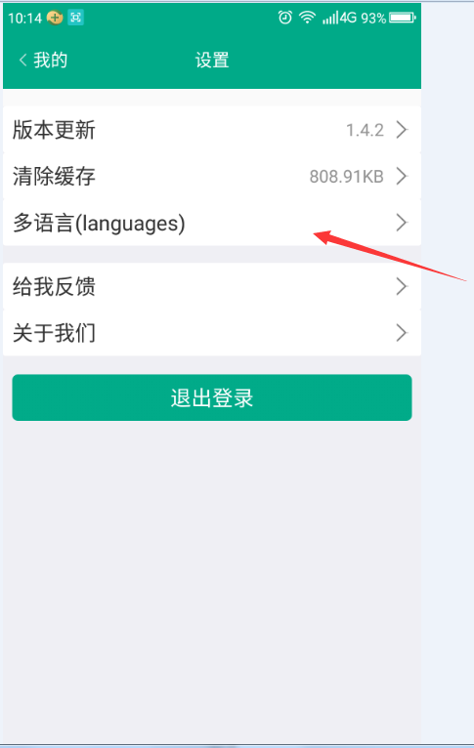

Click language

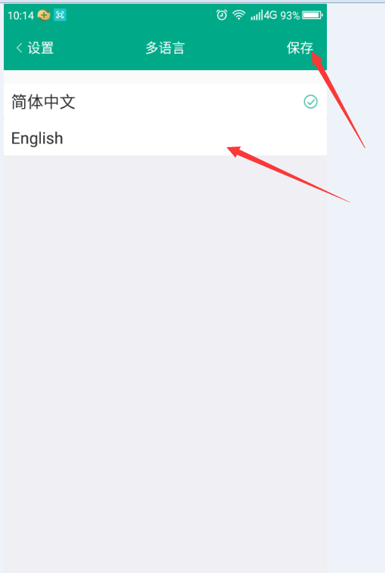

Choose English ,and click ‘save’.

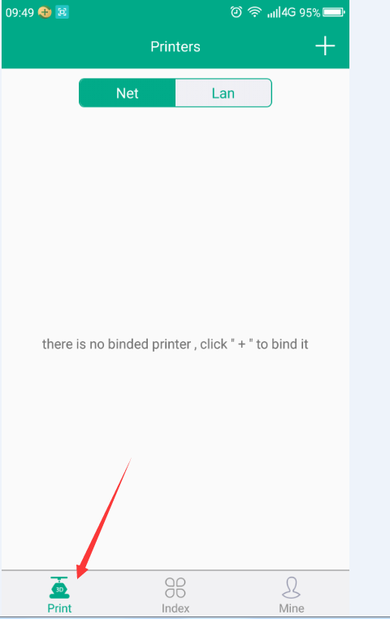

Click ‘print’

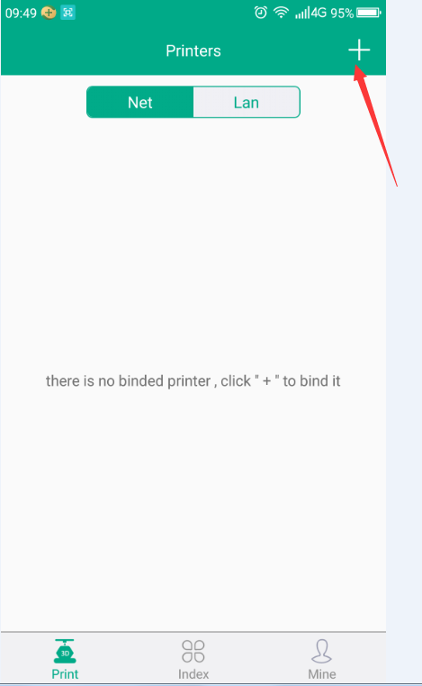

Click ‘+’,choose add a printer by net.

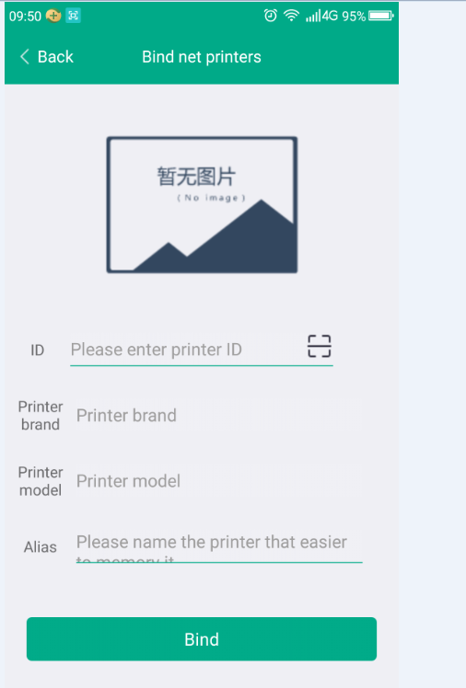

Then This page appears.

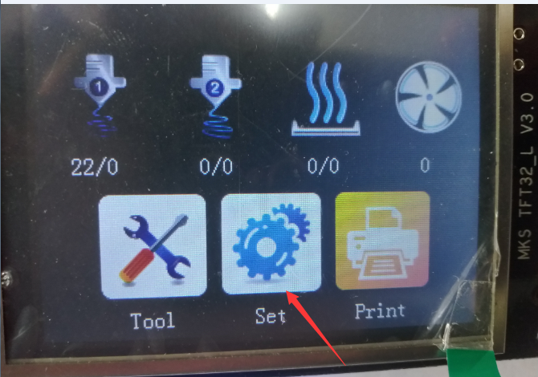

Click ‘set’ in touch screen.

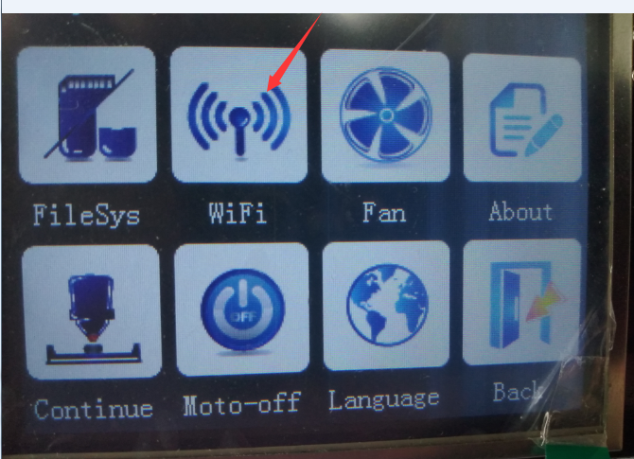

Click ‘WIFI’

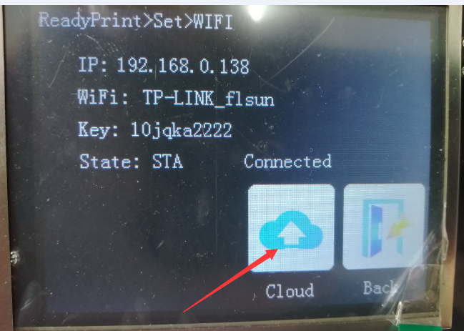

Click ‘Cloud’.

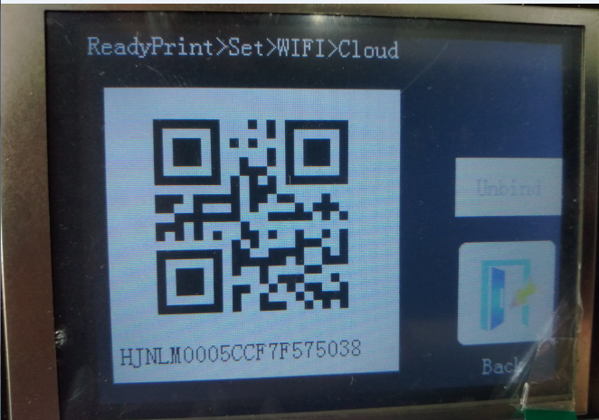

At this time there is a two-dimensional code.

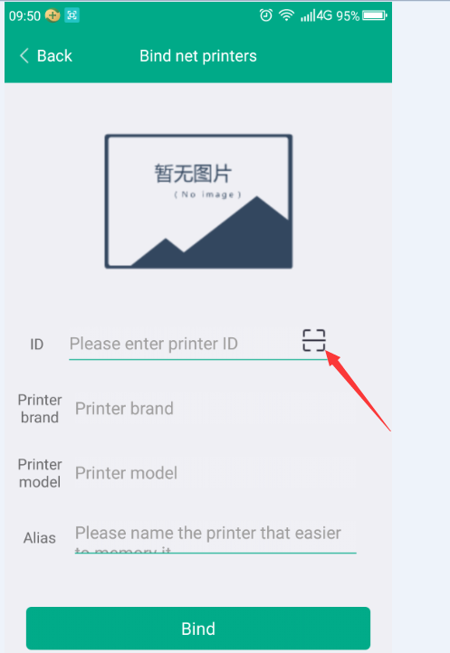

Click this scan two-dimensional code.

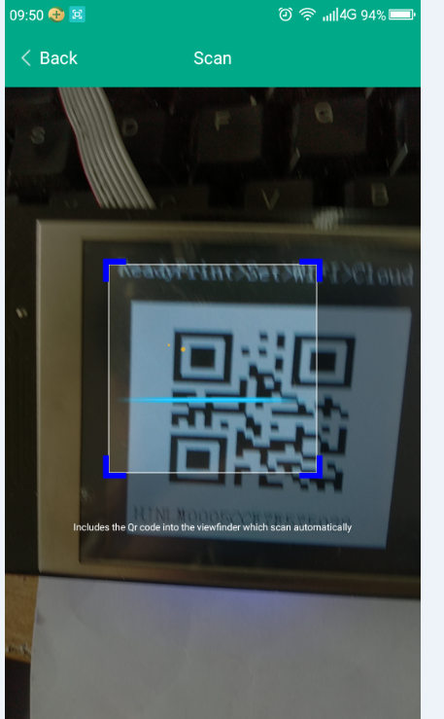

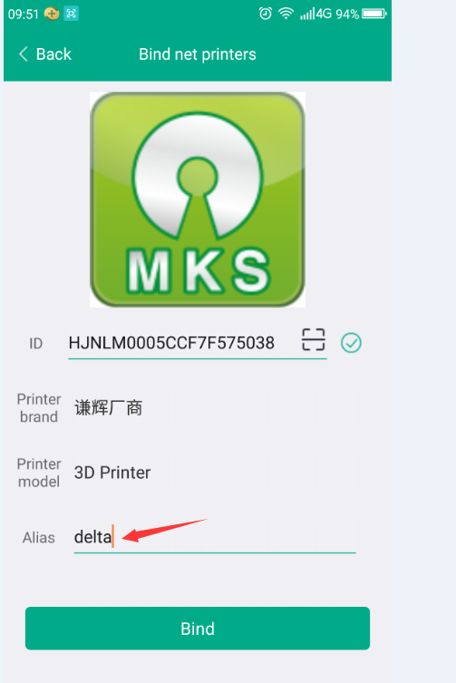

You can name your printer in here. Then click Bind.

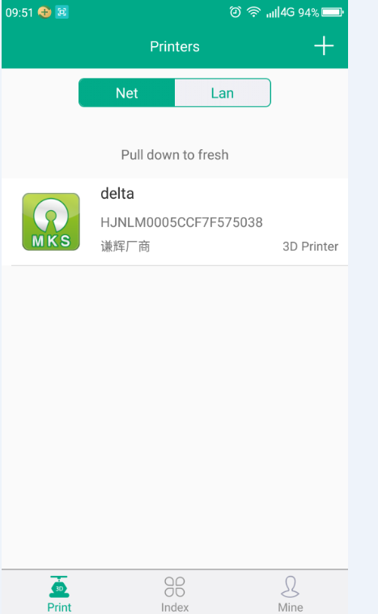

This shows that you have bound a printer.click it enter the control page.

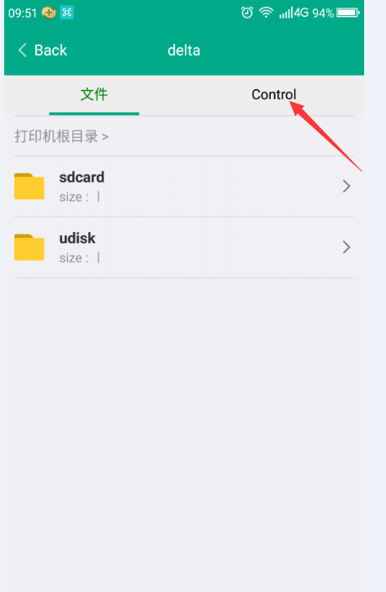

Click control enter control page.

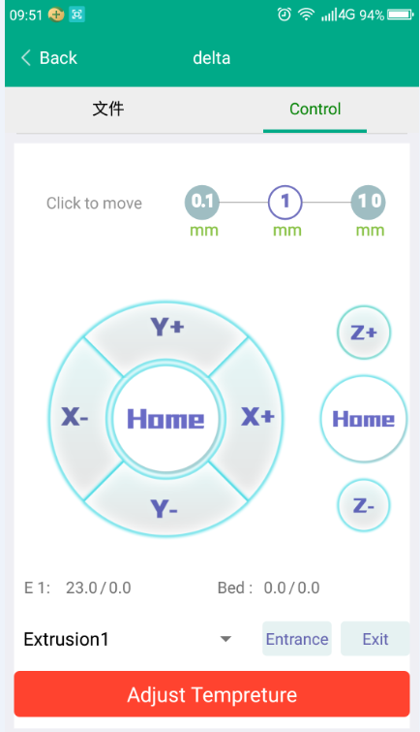

Then you can control printer in control page.print in file page.